Report of “Child Abuse – Rally”

On 10th August 2023, our SSMIET NSS wing took participation in “CHILD ABUSE” Awareness Rally which was conducted by Rotaract Club, Dindigul. Around 80 NSS students and 7 Faculty members participated in this rally. Our volunteers started our rally from Naidu Mahajana Mahal near SP Office, Dindigul at 9.30am. Our volunteers carried awareness boards to create awareness among people. Our volunteers reached the St.Mary’s Higher Secondary School by 10.30 am. The Rotaract Club members explained the importance of Child Abuse. Finally volunteers reached our college by 11.30 am.

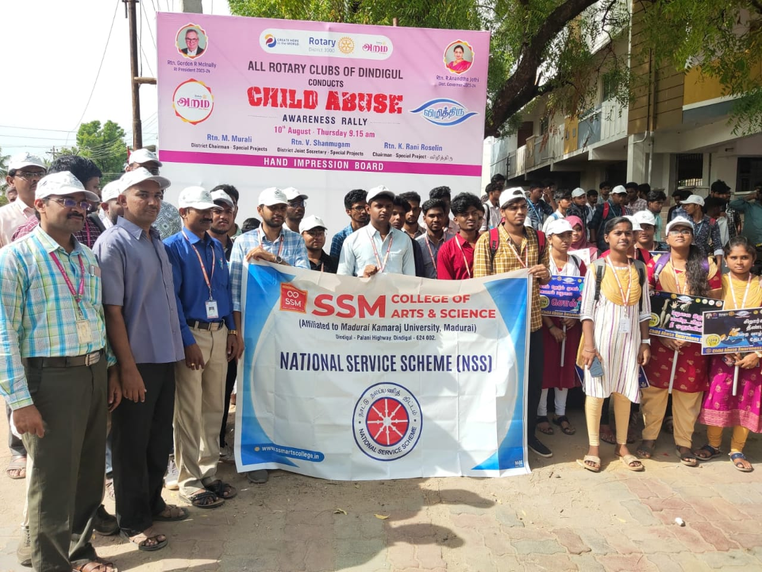 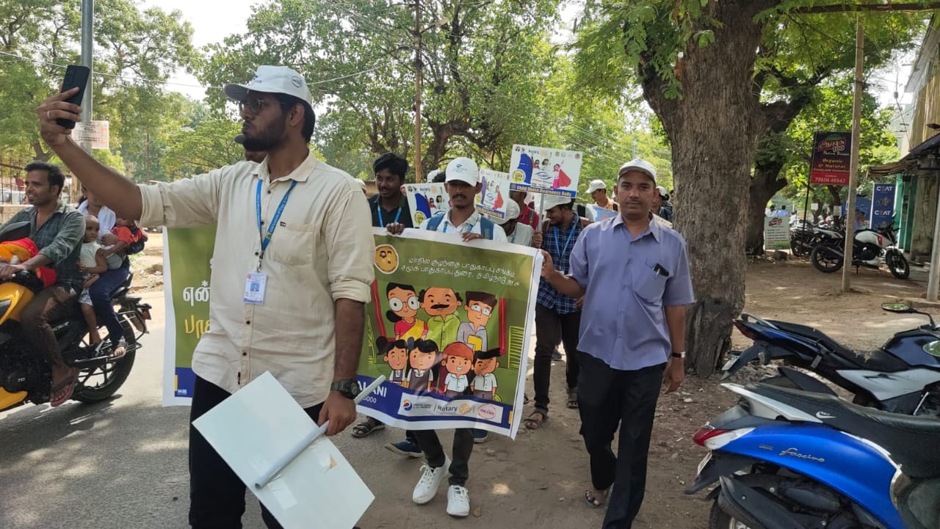

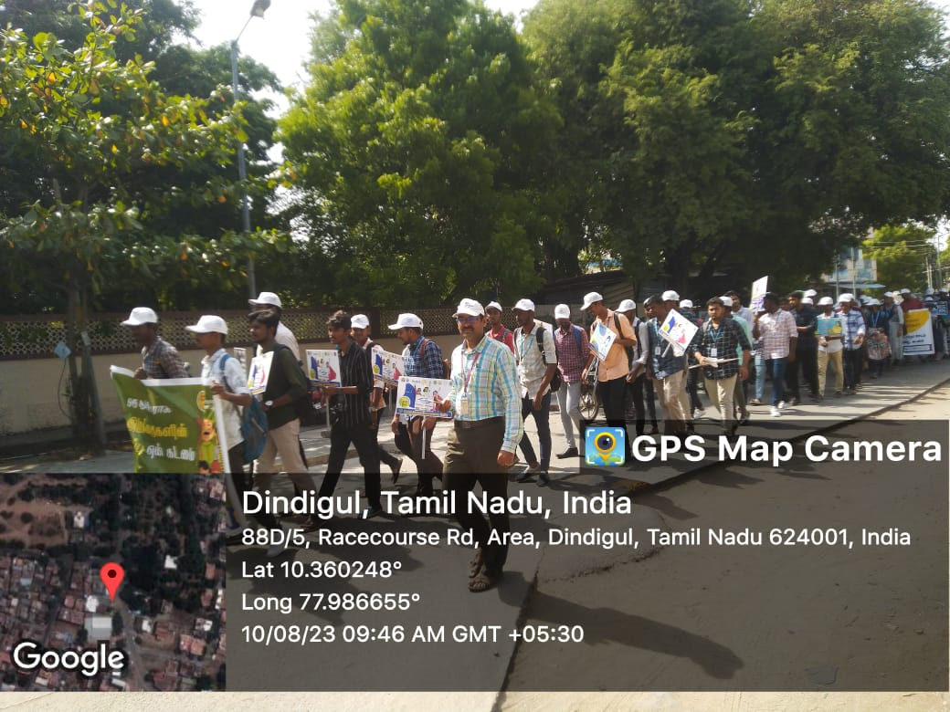 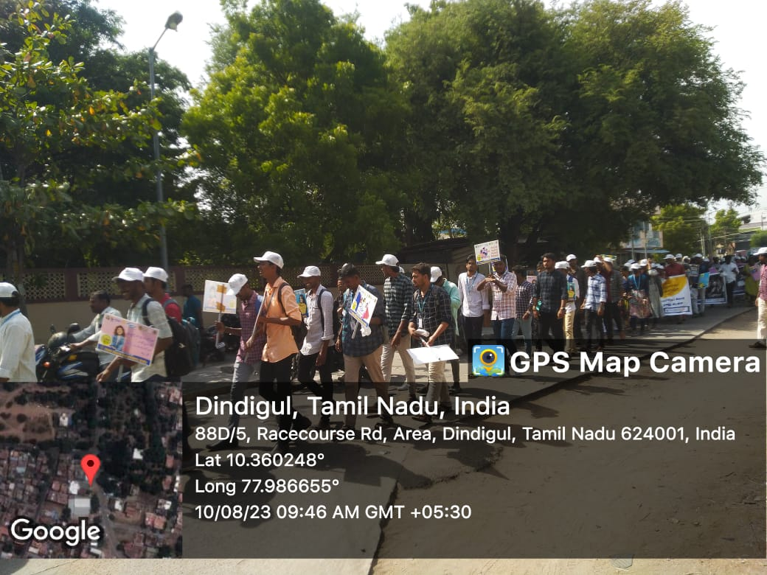

NSS Coordinator Principal